INTEGRATIVE COURSE IN PSYCHOLOGY (ICOPSYCH)

ANALYSIS ON THE RESULT OF PRE-TEST EXAMINATION IN PSYCHOLOGICAL ASSESSMENT
MAY 31, 2025

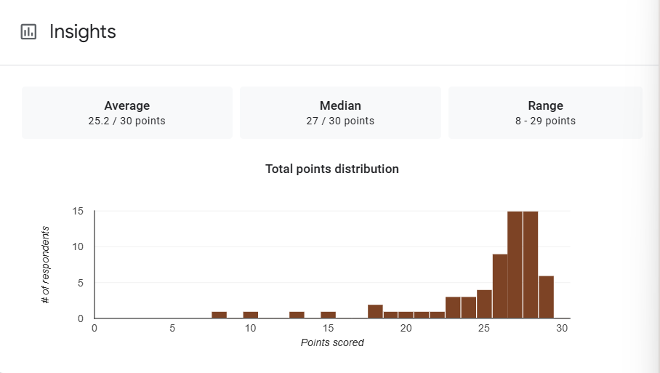

1. Mean Score: The mean score of 25.2 represents 84%, indicating high overall performance among the test-takers. This suggests that, on average, participants had a solid understanding of the test material.

2. Median Score: The median score of 27 is higher than the mean, which indicates a left-skewed distribution. This means that more than half of the participants scored 27 or above, showing that high scores were common, and a few lower scores brought the average down.

3. Range: The range of 21 points shows high variability in performance. This wide spread suggests diverse levels of ability, preparation, or engagement within the group.

Interpretation Summary:

-The test results indicate strong performance overall, with a high mean (25.2) and even higher median (27).

-The wide range (8–29) points to significant variation in individual performance.

-While the majority demonstrated strong understanding, the presence of very low scores suggests that a small number of students may need targeted support or intervention.

RATIONALIZATION:

DIFFICULT QUESTIONS:

